**Experiment: 1**

**Aim:** Accept 5 numbers in an array and display it.

**Software:** Dev C++

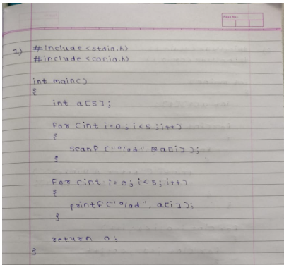**Code:**

**Output:**

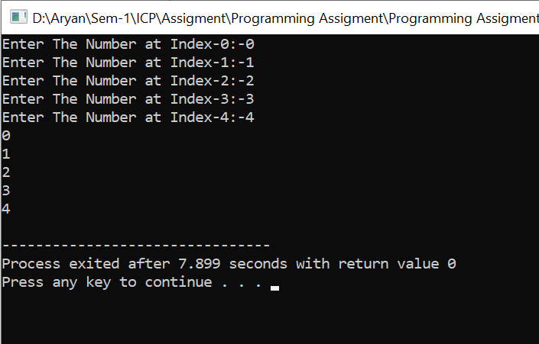

**Experiment: 2**

**Aim:** Accept 4 numbers in 2-d array.

**Software:** Dev C++

**Code:**

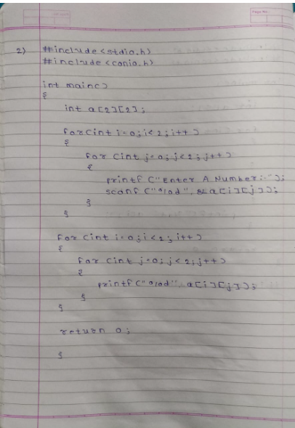

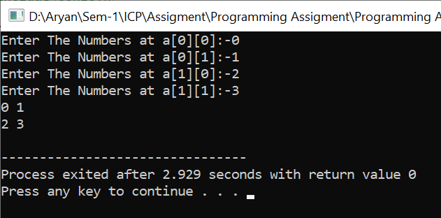**Output:**

**Experiment: 3**

**Aim:**  Write a program to add two matrices.

**Software:** Dev C++

**Code:-**

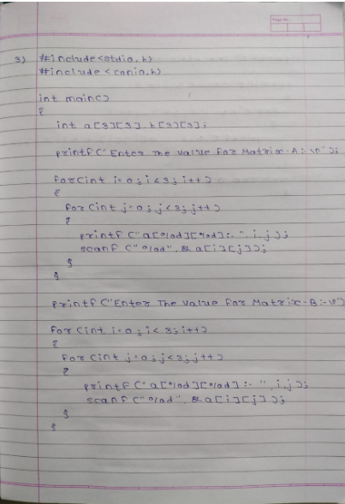 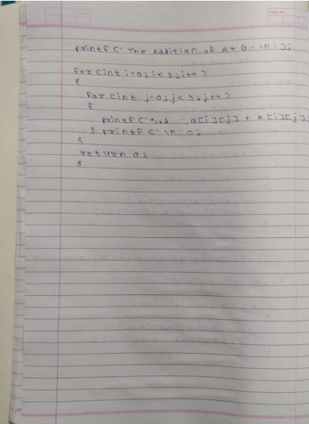

**Output:**

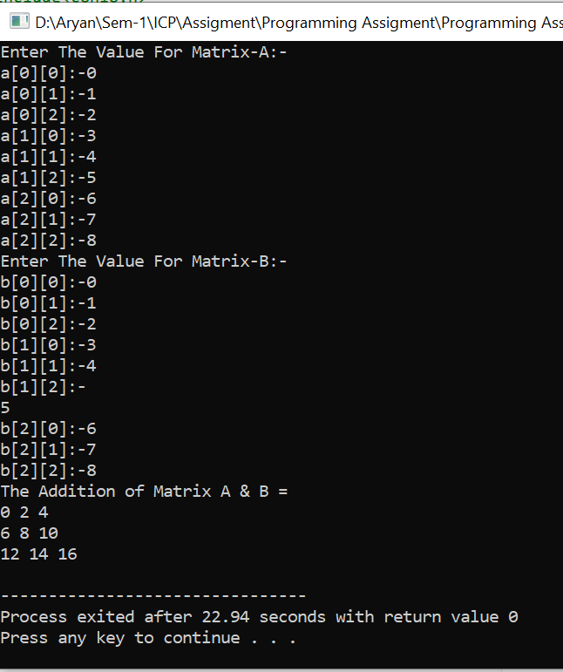

**Experiment: 4**

**Aim:**  Write a program to find out all the even and odd numbers present in an array.

**Software:** Dev C++

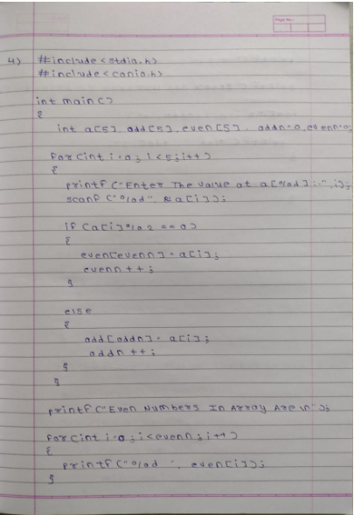**Code:-**

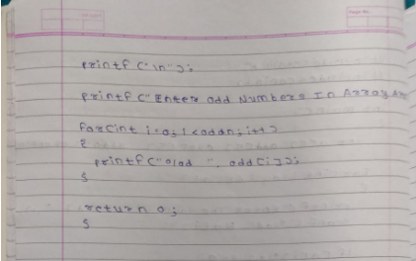

**Output:-**

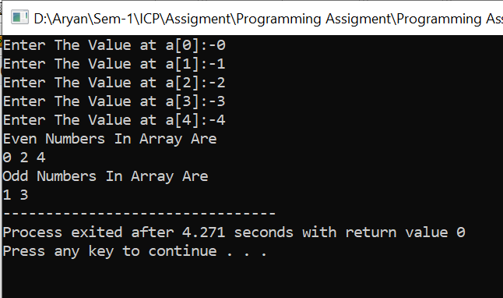

**Experiment: 5**

**Aim:-**  Accept 5 numbers in an array and find maximum and minimum value.

**Software:-** Dev C++

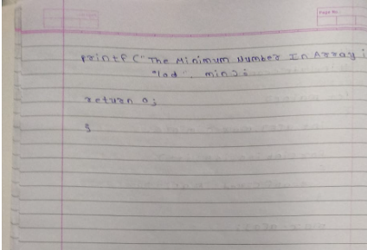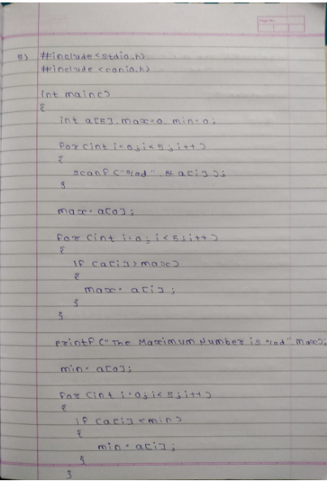**Code:-**

**Output:-**

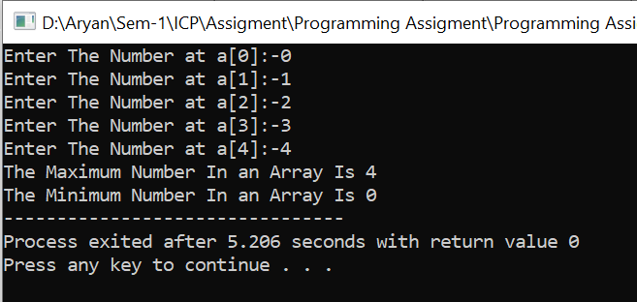

**Experiment: 6**

**Aim:-**  Write a program to delete a word from a string.

**Software:-** Dev C++

**Code:-**

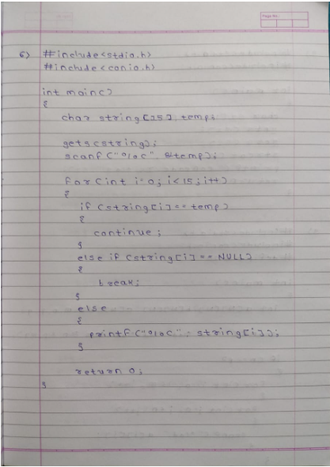

**Output:-**

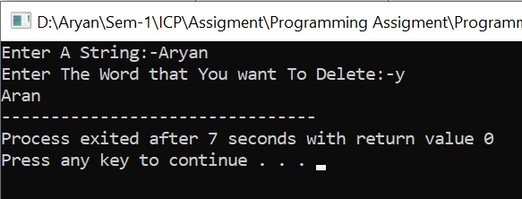

**Experiment: 7**

**Aim:-**  Write a program to find the longest word in a string

**Software:-** Dev C++

**Code:-**

**Output:-**

**Experiment: 8**

**Aim:-**  Get two strings from user and merge it into first string.

**Software:-** Dev C++

**Code:-**

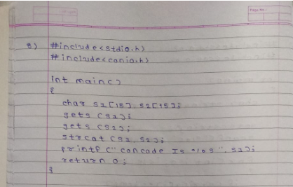

**Output:-**

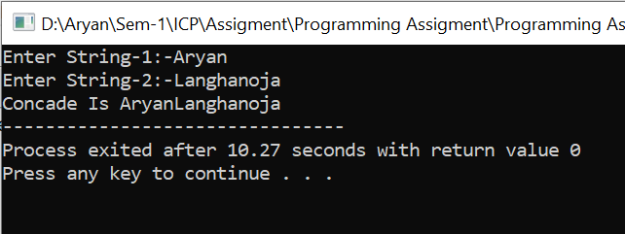

**Experiment: 9**

**Aim:-**  Write a program to multiply two matrices

**Software:-** Dev C++

**Code:-**

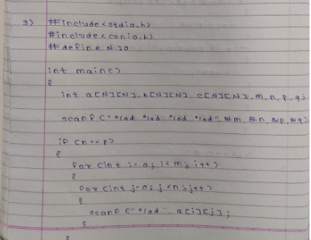 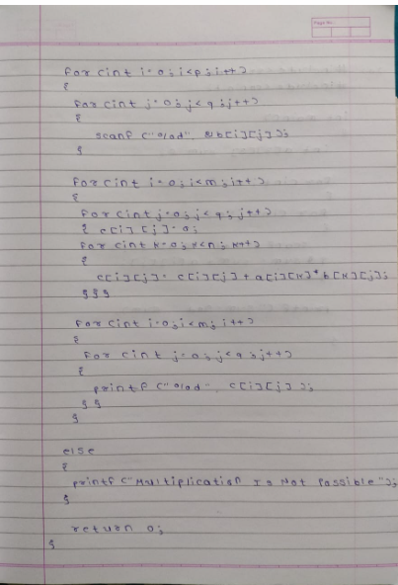

**Output:-**

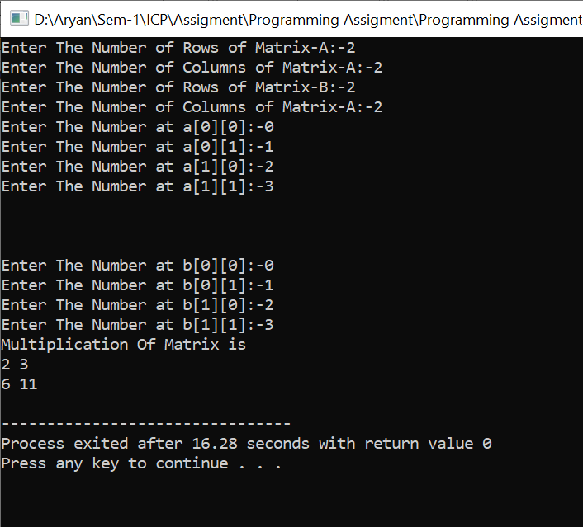

**Experiment: 10**

**Aim:-**  Write a program to add all the elements of a matrix

**Software:-** Dev C++

**Code:-**

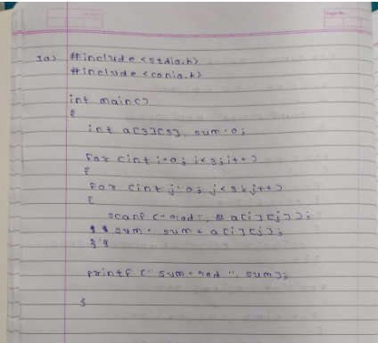

**Output:-**

